2. Implement programs for visualizing time series data
AIM:
To implement programs for visualizing time series data
PROCEDURE:
- Import the necessary libraries:
from google.colab import files
uploaded = files.upload()
import pandas as pd
- Load the dataset:
import io
df = pd.read_csv(io.BytesIO(uploaded["autism.csv"]))
print(df)

- Implementing program for visualising time series data using scatter plot.
import matplotlib.pyplot as plt
import seaborn as sns
plt.figure(figsize=(10, 6))

plt.scatter(df['age'], df['result'])
plt.xlabel('age')
plt.ylabel('result')
plt.title('Scatter Plot of Time Series Data')
plt.show()
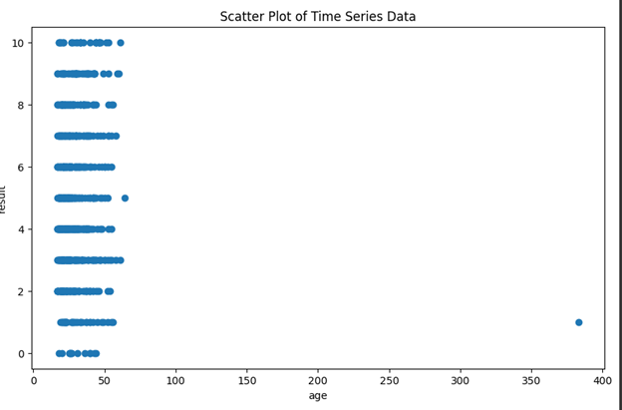

4. Implementing program for visualising time series data using area plot.
plt.figure(figsize=(10, 6))
plt.stackplot(df['age'], df['result'])
plt.xlabel('age')
plt.ylabel('result')
plt.title('Area Plot of Time Series Data')
plt.show()
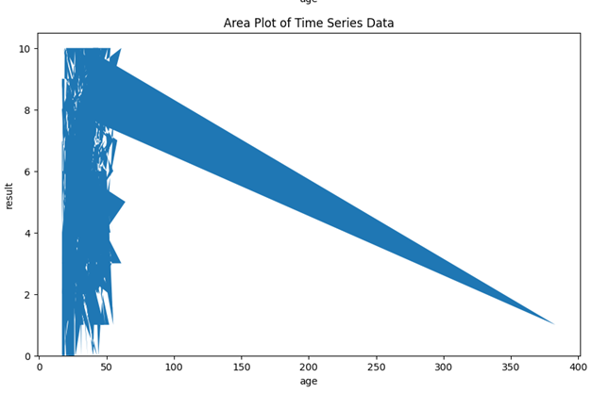

5. Implementing program for visualising time series data using line plot.
plt.figure(figsize=(10, 6))
plt.plot(df['age'], df['result'])
plt.xlabel('age')
plt.ylabel('result')
plt.title('Line Plot of Time Series Data')
plt.show()

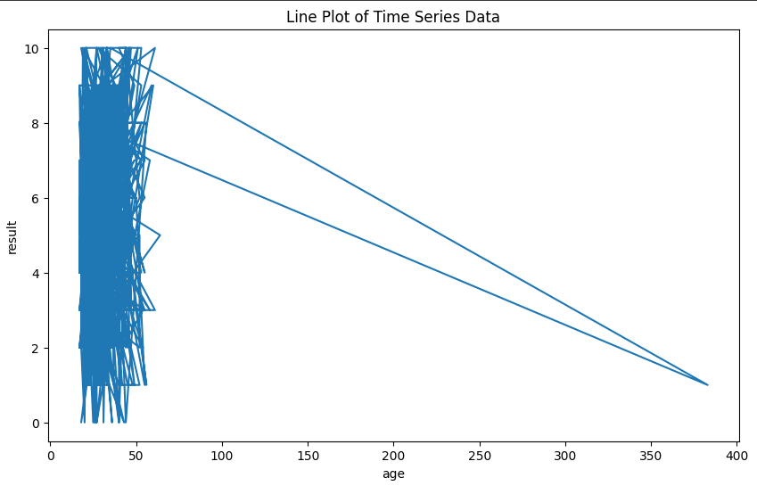

6. Implementing program for visualising time series data using box plot.

plt.figure(figsize=(10,6))
sns.boxplot(x=df['age'], y=df['result'])
plt.xlabel('age')
plt.ylabel('result')
plt.title('Box Plot of Time Series Data')
plt.show()
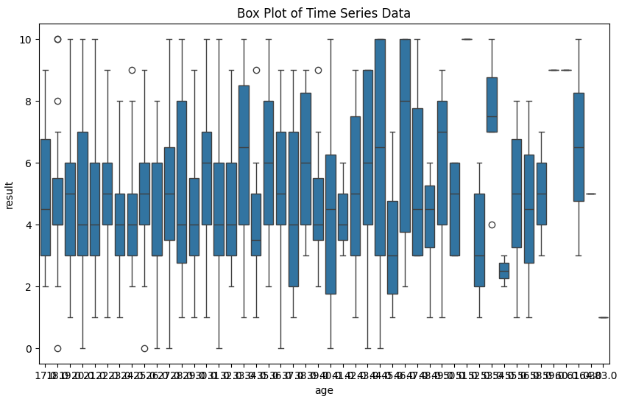

7. Implementing program for visualising time series data using bar plot.
plt.figure(figsize=(10, 6))
# Replace 'A1' and 'A2' with the correct column names from your DataFrame
plt.bar(df['age'], df['result'])
plt.xlabel('age')
plt.ylabel('result')
plt.title('Bar Plot of Time Series Data')
plt.show()
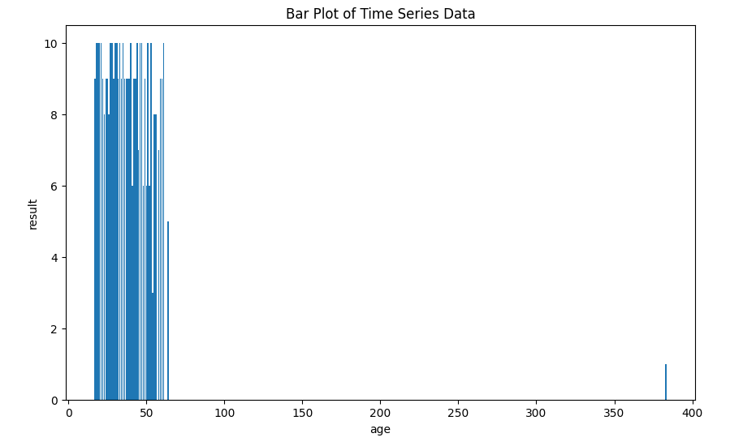

RESULT:
The programs for implementing for visualizing time series data is verified successfully.

